**FINALL REPORT ON DANCE FESTIVALS PROJECT**

**(USING Web Development)**

SUBMITTED IN PARTIAL FULFILMENT OF THE REQUIREMENT FOR THE

AWARD OF THE DEGREE OF

**BACHELOR OF ENGINEERING**

**(INFORMATION TECHNOLOGY)**



**Supervisor** **Submitted By:**

Dr. Sukesha Munna Kumar

UE188064

IT B,5th sem.

To

Department of Information Technology

University Institute of Engineering and Technology

Panjab University, Chandigarh

2021

**UNDERTAKING BY STUDENT**

I the student of Bachelor of Engineering in Information and Technology in

**UIET, PANJAB UNIVERSITY** have enrolled myself for the course ‘Front-End Web UI Frameworks and Tools: Bootstrap 4 ,by The Hong Kong University of Science and Technology’ offered by Coursera from 31st May, 2020 to 19th July, 2020.

NAME: ROLLNO: SIGNATURE

Munna Kumar UE188064 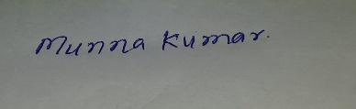

**Acknowledgement**

I would like to express my deepest appreciation to all those who provided me the possibility to complete this report. Firstly, I would like to thank Dr. Savita Gupta (Director of UIET, Panjab University) for meticulously planning academic curriculum , in such a way that students are not only academically sound but also industry ready by including such industrial training patterns.

I would also like to express my thankfulness to Dr. Krishan Saluja (Head of Department , Information and technology) for providing us with the opportunity to enhance our skills through industrial training This was quite a great experience I can learn from. It helped me to explore my skills and increased my interest in web development (Front End/Backend).

I have to appreciate the guidance given by other supervisor as well as the panels especially in our project presentation that has improved our presentation skills thanks to their comment and advices.

**Introduction about PHP**

PHP is server side scripting language. PHP begin as a **PERSONAL HOME PAGE** scripting tool. Today PHP is widely used in personal and corporate world as an efficient web development plate form. In most cases PHP is introduced in corporation because of its speed and absence of license fees.

**PHP**

* PHP stands for PHP: Hypertext Preprocessor
* PHP is a server-side scripting language, like ASP
* PHP scripts are executed on the server
* PHP supports many databases (MySQL, Informix, Oracle, Sybase, Solid, PostgreSQL, Generic ODBC, etc.)
* PHP is an open source software
* PHP is free to download and use

**Characteristics of PHP**

* **Readable** – Being able to easily read code is vital. Don’t ever assume you will be the only developer to ever read and maintain your code. I can’t think of a single project for the exception of my blog that I have been the only one who worked on it. Readable code has meaningful variables; good comments that help describe what’s going on. However, good variables and comments doesn’t necessarily mean your code is readable.
* **Organized** – While some people think this is the same as readable, organization is different and crucial to me. Readability is the ability to read your code, however organized code helps you find what your looking for. There are many techniques to help keep your code well organized, but the most important thing is at the end of the day, can your fellow developers find what they are looking for?
* **Modular** – I hear this word tossed around a lot when talking about programming. However, what really is modular? I like to define it as being able to take a part of your code and use it elsewhere with the least amount of headache.
* **Relevant** – While I hear a lot about Modular code, I don’t hear a lot about relevant code. While people might consider relevant in the modular or organized characteristic, I find it helps me to separate this out. Relevant to me means that code is where it belongs. Its easy to have code blur together and have purposes mixed. Relevant code means the grouping of code belongs together.
* **Efficient** – What good is code if it is slow, doesn’t scale, and will have to be re-written? Is being efficient is just following a handful of rules and guidelines?
* **Practical** – It may be efficient, it be organized, but is it practical? In the past I’ve written the “coolest” class, or so I thought, only to have a fellow developer tell him that my implementation is confusing, and overly complex. While many times we create code that isn’t robust enough, but it is possible to make stuff just complicated, over-designed, or just impractical. Keeping your code practical helps you and your team to make a good solution that is easy to maintain.
* **Documented** – Code that isn’t well documented will be a time drain. I know many developers who think keeping up documentation slows the development process down.
* However, without that documentation, the overall development process will suffer. Bringing new developers up to speed, maintenance, even just general development will be slowed down by “figuring stuff out.” Documentation is also more than just having a “wiki” or using comments.
* **Longevous** – The definition is to live a long life. There are two parts to having longevous code. First of all, when you’ve programmed or maintained some code, ask yourself. “How long will this last? Will this solution work well over time?” Then, the second part which I think is almost never asked: “when the time comes, how easily can I extend, or replace this code?” To often programmers “dig ruts” so-to-speak projects. They code an aspect of a project that locks them into a situation that is extremely difficult to code out of.
* **Secure** – All of the time spent on development can be for nothing if it isn’t secure. Security in web development is a must. It doesn’t matter the size of the website, large or small, eventually someone will try to break it. Someone will try to compromise it. The consequences vary, from an annoyance, to destroying the entire business. Making your application secure is a skill all developers need.
* **Safe** – While some people think of this as the same as secure, for me safe PHP code means it errors correctly. Great PHP code handles errors correctly. If a PHP class fails, it should handle the error properly. It properly let me know when it is not.

**Applications of PHP**

Web Database Applications with PHP and MySQL offers web developers a mixture of theoretical and practical information on creating web database applications. Using PHP, and MySQL, two open source technologies that are often combined to develop web applications, the book offers detailed information on designing relational databases and on web application architecture, both of which will be useful to readers who have never dealt with these issues before. The book also introduces Hugh and Dave's OnlineWines, a complete (but fictional) online retail site that allows users to browse, search a database, add items to a shopping cart, manage their membership, and purchase wines. Using this site as an example, the book shows you how to implement searching and browsing, store user data, validate user input, manage transactions, and maintain security.

**Technology used**

**Server Side Technologies**

For server-side programming you will need a web server on your machine. This can be IIS on a Windows platform or something like Apache for other operating systems. Apache dominates the web server scene, currently powering 60% of the Web. In order to use the server-side scripting tool you will need to install and configure the PHP language in interpreter on your server.

* PHP.
* AJAX.

**Client Side Technologies**

* JavaScript.
* HTML.
* CSS.
* J-Query.

**Database used for these products**

* MY SQL

**ABOUT TRAINING**

During our training we have study about.

* Introduction of HTML.
* DHTML
* CSS
* JAVA SCRIPT
* PHP

**HARDWARE AN SOFTWARE TO BE USED**

The success of any running project primarily depends upon Hardware and Software in its compilation. The hardware used in the machine should be such that it supports the software that is to be mounted for assembling the project. This project deals with the hardware and software which is available reading and easy on each and every machine given to the user.

**1.** **Operating System: - Windows 10**

**2. Framework 3.5**

.

**Objectives of project**

* Providing user friendly interface
* Keeping project records online
* To get all the information about the schoola and universities online
* Easy access of data
* Easy maintence
* Maintaining data conisistency
* Providing better performance
* Increasing the efficiency through automation
* Adequate security of the database
* Adequate validation checks for data entry
* Facility to update the data time to time

**Scope of the Website**

Educational technology is a process- oriented technique. Educational technology is not limited to teaching and learning process and theories still teaching-learning process is influenced much more by educational technology. Theories have been shifted from learning to teaching only due to educational technology.

If the educational technology is limited to audio-visual aids, mechanical and electronic gadgets the scope of educational technology becomes limited, but educational technology is not limited to all these things rather, it pervades all over. Educational technology should go into:

1. At home.

2. Managed by external assistance.

3. Rigorous task analysis.

4. Specification of direct behavior.

5. Determination of pre-requisites and the gradual direct behavior.

6. Clear specification of the problem.

7. Hindrance in solving problems.

8. Management and organization of man, material, resources.

9. Availability of a few media as for example films, television, radio etc.

10. Developing software technology.

believe in providing a workable solution. INFOWIZ offers research based Search Engine Marketing products that help achieve greater insights to customer’s online business. Our Research & Development arm offers SEO tools for SEM professionals.

INFOWIZ also provides Technical Support & Consultancy to Software Companies like JIA Group, Newzealand, Sagitech solutions Panchkula, Jarc infotech Mohali, Infonet Solution, Delhi etc.

**Introduction to JavaScript**

JavaScript is most commonly used as a client side scripting language. This means that JavaScript code is written into an HTML page. When a user requests an HTML page with JavaScript in it, the script is sent to the browser and it's up to the browser to do something with it.

The fact that the script is in the HTML page means that your scripts can be seen and copied by whoever views your page. Nonetheless, to my mind this openness is a great advantage, because the flip side is that you can view, study and use any JavaScript you encounter on the WWW.

JavaScript can be used in other contexts than a Web browser. Netscape created server-side JavaScript as a CGI-language that can do roughly the same as Perl or ASP. There is no reason why JavaScript couldn’t be used to write real, complex programs. However, this site exclusively deals with the use of JavaScript in web browsers.

If you don’t have any programming experience at all it’s best to start with some gentle JavaScript examples that teach you the basics. It might be a good idea to buy Negrino & Smith, **“**[**JavaScript for the World Wide Web**](http://www.javascriptworld.com/)”, 4th edition, Peachpit Press, 2001. It contains some very useful examples and though it doesn’t treat advanced programming tricks, it will certainly help you get started. Of course this site also offers plenty of help.

I can also recommend Jeremy Keith, [**DOM Scripting: Web Design with JavaScript and the Document Object Model**](http://domscripting.com/book/)**,** 1st edition, Friends of Ed, 2005. This, too, is a book that doesn't delve too deeply into technology, but gives non-programmers such as graphic designers/CSS wizards an excellent overview of the most common uses of JavaScript - as well as the most common problems.

JavaScript is Netscape's cross-platform, object-based scripting language for client and server applications. JavaScript lets you create applications that run over the Internet. Client applications run in a browser, such as Netscape Navigator, and server applications run on a server, such as Netscape Enterprise Server. Using JavaScript, you can create dynamic HTML pages that process user input and maintain persistent data using special objects, files, and relational databases. Through JavaScript's Live Connect functionality, your applications can access Java and CORBA distributed-object applications.

**jquery**

## Introduction

[**JQuery**](http://jquery.com/), an extremely popular, open source JavaScript library. We will start by looking at the current state of the art in JavaScript technology to see why JQuery is used in many impressive applications.

We will then use our case study from the first article in order to create a simple HTML page, which will serve as the basis for a hands-on tutorial for performing the following tasks using JQuery functionality:

* Selecting HTML elements with JQuery
* Manipulating HTML elements
* Adding some animations to the Web page
* Using JQuery UI to add a custom theme
* Extending JQuery with the numerous available plug-in

At the end of this article, we will have a user-friendly HTML and JavaScript front end, ready to be used for our application.

## Why Use JQuery Instead of Just Basic JavaScript?

JavaScript is a fairly low-level programming language. It does not provide advanced page manipulation and decoration functions, and it provides nothing concerning animations. Moreover, using direct JavaScript can cause issues related to browser incompatibilities. Those issues have made many JavaScript applications difficult to code, resulting in high maintenance costs.

JQuery aims to ease all these problems by providing a lightweight library that adds many advanced and cross-browser functions to the standard language. In addition, there is a very dynamic community that adds more-advanced components based on JQuery.

A modern Web application wouldn't be complete without some AJAX functionality. JQuery provides functions for sending HTTP GET and POST requests, and it can work easily with the JavaScript Object Notation (JSON) format we saw in the first article. This functionality enables us to query the REST back end we coded in the first article.

## Installing JQuery

JQuery is a JavaScript library, so installing it is just a matter of importing a script inside a Web page. However, there are a few best practices to be aware of:

* JQuery is available through several content delivery networks (CDN). Using those CDNs instead of installing s JQuery on your servers should provide significant performance and bandwidth gains.
* As with any static content, JQuery files should be served compressed. That's why there are two versions of JQuery available: a minified (or “min”) version, which is small and efficient, and a development version, which is easier to read and debug. For the rest of this article, we will use the min version, which is enough for our needs.
* JQuery files should be cached on the client side, so you should use the JQuery version number in the file name.

Let's start with a simple HTML Web page, which will be used for our sample application.

**CSS**

A CSS (cascading style sheet) file allows you to separate your web sites (X)HTML content from it’s style. As always you use your (X)HTML file to arrange the content, but all of the presentation (fonts, colors, background, borders, text formatting, link effects & so on…) are accomplished within a CSS.

At this point you have some choices of how to use the CSS, either internally or externally.

## Internal Stylesheet

First we will explore the internal method. This way you are simply placing the CSS code within the <head></head> tags of each (X)HTML file you want to style with the CSS. The format for this is shown in the example below.

With this method each (X)HTML file contains the CSS code needed to style the page. Meaning that any changes you want to make to one page, will have to be made to all. This method can be good if you need to style only one page, or if you want different pages to have varying styles.

## External Stylesheet

Next we will explore the external method. An external CSS file can be created with any text or HTML editor such as “Notepad” or “Dreamweaver”. A CSS file contains no (X)HTML, only CSS. You simply save it with the .css file extension. You can link to the file externally by placing one of the following links in the head section of every (X)HTML file you want to style with the CSS file.

By using an external style sheet, all of your (X)HTML files link to one CSS file in order to style the pages. This means, that if you need to alter the design of all your pages, you only need to edit one .css file to make global changes to your entire website.

Here are a few reasons this is better.

* Easier Maintenance
* Reduced File Size
* Reduced Bandwidth
* Improved Flexibility

## Cascading Order

In the previous paragraphs, I have explained how to link to a css file either internally or externally. If you understood, than I am doing a good job. If not don’t fret, there is a long way to go before we are finished. Assuming you have caught on already, you are probably asking, well can I do both? The answer is yes. You can have both internal, external, and now wait a minute a third way? Yes inline styles also.

### Inline Styles

I have not mentioned them until now because in a way they defeat the purpose of using CSS in the first place. Inline styles are defined right in the (X)HTML file along side the element you want to style. See example below.

**Introduction to AJAX**

Ajax (shorthand for asynchronous JavaScript and XML) is a group of interrelated web development techniques used on the client-side to create interactive web applications. With Ajax, web applications can retrieve data from the server asynchronously in the background without interfering with the display and behavior of the existing page. The use of Ajax techniques has led to an increase in interactive or dynamic interfaces on web pages. Data is usually retrieved using the XMLHttpRequest object. Despite the name, the use of JavaScript and XML is not actually required, nor do the requests need to be asynchronous.

Like DHTML and LAMP, Ajax is not a technology in itself, but a group of technologies. Ajax uses a combination of:

* HTML and CSS for marking up and styling information.
* The DOM accessed with JavaScript to dynamically display and interact with the information presented.
* A method for exchanging data asynchronously between browser and server, thereby avoiding page reloads. The XMLHttpRequest (XHR) object is usually used, but sometimes an I Frame object or a dynamically added <script> tag is used instead.
* A format for the data sent to the browser. Common formats include XML, pre-formatted HTML, plain text, and JavaScript Object Notation (JSON). This data could be created dynamically by some form of server-side scripting.

**INTRODUCTION**

**PROJECT DESCRIPTION**

Punjabi dances are an array of folk and religious dances of the Punjabi people. The style of Punjabi dances ranges from very high energy to slow and reserved, and there are specific styles for men and women. The dances are typically performed at a times of celebration, such as visakhi, weddings, festivals like lohri etc.

At which everyone is encouraged to dance. Married Punjabi couples usually dance togethers. The husband dances in style of male Punjabi dances and the wife dances in the style of female Punjabi dances. Dance, being a part of man’s life from the primitive to the most cultured community, appears to have evolved even before he began to speak or paint. While the primitive man performed the dance combining the reality with the deity, the cultured man performed the dance for pleasure and for the expression of art.

India, the land of great cultural heritage with its vast variety of races and conditions has been a veritable treasure house of dance forms for untold centuries. It has given birth to varied forms of dancing, each shaped by the influences of a particular period and environment. Most of the prevailing systems of Indian classical dances which are governed by elaborate techniques and shown high degree of refinement have had their origin in the dances of the common people, which still survive in as virile state as ever in tribal hamlets and peasant huts.

The Indian folk dance is a creative work with the artistic steps and postures being accompanied by the rhythmical movements of vocal or instrumental music. The Indian folk dance has an age old tradition and is simple without being naïve. In folk tradition, dance is nourishment to the daily life of the people. Every folk dance portrays some expression of life and meaning. Its profundity of conception and a directness of expression are of great artistic value.

The concept of portraying emotion in a folk dance is natural and original. More than the grace of the individual dancer or the virtuosity of the isolated prose, the total effect of the overwhelming buoyancy of spirit, and the eloquent, effortless ease with which it is expressed are important. Being less complex in technique, it is governed by a broad set of rules which vary from dance to dance and from region to region.

**Common Punjabi folk dances for “Females”**

* Sammi
* Gidha
* Jaago
* Kikli

**Common Punjabi folk dances for “Males”**

* Bhangra
* Malwai Giddha
* Mirza
* Jugni

**See also**

* Bhangra
* Giddha
* Sammi

**Information About Dance**

* Roles of the Dance Teacher.
* Cultural Education.
* Planning a Dance Programming.
* Safe Practices.
* Giving and Receiving Feedback.
* Identify and Providing for Talent.
* Resources and Technology.
* Speed /slow.
* Musically.
* Styling.
* Timing.
* Teamwork/Parternship.

**Roles**

* Creator
* Performer
* Audience
* Critic
* Leader

**Activities**

* Dancing
* Creating
* Performing

**Modules of Dance**

* Online Registration .
* Online Classes.
* Online Payment.
* Online Home Dance Classes

**Objectives of Dance**

* Dance will acquire proficiency in and understanding of multiple dance disciplines.
* Dance will develop the ability to assess their own dancing and experiences.
* We will learn to determine and express their own strengths and weaknesses.
* We will develop personal pathways to success.
* We will grow as choreographers and performers.
* Dance will acquire basic musical skills and a more comprehensive understanding of musicality.
* Students will develop basic production skills.
* We will learn the basic skills required to create and run a dance company.

**COMPONENTS OF PROJECT**

**The main components of dance**

- Flexibility

- Balance

- Coordination

- Stamina

- Muscular strength

- Muscular endurance

- Agility

- Timing

- Speed

**MODULES**

* Login
* Contact Us
* Compitition
* Online Registration
* Dance Classes
* Online Classes
* Online Home Dance Classes

**INTRODUCTION TO TOOL**

**FRONT-END**

**Front-End:** Web Pages using PHP, HTML, and JavaScript.

* **PHP**- PHP is a technology that lets you mix regular, static HTML with dynamically-generated HTML. Many Web pages that are built by CGI programs are mostly static, with the dynamic part limited to a few small locations. But most CGI variations, including servlets, make you generate the entire page via your program, even though most of it is always the same.
* **HTML** –It is used to generate web page. HTML, an initialism of Hypertext Markup Language, is the predominant [markup language](http://en.wikipedia.org/wiki/Markup_language) for [web pages](http://en.wikipedia.org/wiki/Web_page). It provides a means to describe the structure of text-based information in a document — by denoting certain text as headings, paragraphs, lists, and so on.
* **JAVASCRIPT –** It is used for checking User information before sending to JavaScript is a [scripting language](http://en.wikipedia.org/wiki/Scripting_language) most often used for [client-side](http://en.wikipedia.org/wiki/Client-side) web development. It is a [dynamic](http://en.wikipedia.org/wiki/Dynamic_language), [weakly typed](http://en.wikipedia.org/wiki/Weak_typing), [prototype-based](http://en.wikipedia.org/wiki/Prototype-based_programming) language with [first-class functions](http://en.wikipedia.org/wiki/First-class_function). Currently, "JavaScript" is an implementation of the [ECMA Script](http://en.wikipedia.org/wiki/ECMAScript) standard.

**BACK-END**

**Back-End:** MySQL

* **MySQL**- MySQL is the world's most popular open source database software, with over 100 million copies of its software downloaded or distributed throughout it's history. With its superior speed, reliability, and ease of use, MySQL has become the preferred choice for Web, Web 2.0, SaaS, ISV, Telecom companies and forward-thinking corporate IT Managers because it eliminates the major problems associated with downtime, maintenance and administration for modern, online applications.
* Many of the world's largest and fastest-growing organizations use MySQL to save time and money powering their high-volume Web sites, critical business systems, and packaged software — including industry leaders such as Yahoo!, Alcatel-Lucent, Google, Nokia, YouTube, Wikipedia, and Booking.com.
* The flagship MySQL offering is MySQL Enterprise, a comprehensive set of production-tested software, proactive monitoring tools, and premium support services available in an affordable annual subscription.
* MySQL is a key part of LAMP (Linux, Apache, MySQL, PHP / Perl / Python), the fast-growing open source enterprise software stack. More and more companies are using LAMP as an alternative to expensive proprietary software stacks because of its lower cost and freedom from platform lock-in.
* MySQL was originally founded and developed in Sweden by two Swedes and a Finn: David Axmark, Allan Larsson and Michael "Monty" Widenius, who had worked together since the 1980's.

**REQUIRMENT ANALASIS**

**Hardware Requirements**

|  |  |
| --- | --- |
| Number | Description |
| 1 | Intel core ,WIN xp/7/vista |
| 2 | 320 MB RAM |

**Software Requirements**

|  |  |
| --- | --- |
| Number | Description |
| 1 | Windows XP –7 |
| 2 | Php 5.1 |
| 3 | MySql |
| 4 | IIS server/ WAMPSERVER |
| 5 | HTML/DHTM/AJAX/JavaScript/CSS/  flash 8 |

**DFD**

Physical Setting

Costume, Lighting, Film, Theater, Site

Dancers

Partners and Group Realtionship

Dance Idea

Movement

Action ,Gesture, Dynamics, Stillness.

Aural Setting

Music, Sound effects, Voice, Slience.

Structure

Decices/Fhrase and development, Sectioning, Contrast, Balance, Unity, Theame and Varition

**RESULTS & DISCUSSION**

A series of ADF programs on "Dance, Culture and Humanities" and "Dances and Their People" has been presented at Duke University in Durham, North Carolina for over a decade. The participating scholars and choreographers, assisted by dancers illustrating their discussions, have shown how dance is a window on culture; how it provides insight into the life and times of a society or civilization. Ancestral, ritualistic, and folk dances have long been sources of information about the work habits, daily routines, and the beliefs and values of the cultures to which they belonged, and this was illustrated, in the case of Native American traditions, by a tribal group from North Carolina, with interpretations by Jamake High water.

**"Dances and Their People"** looked at dance styles and their cultural origins, including African American, Japanese, French, and Spanish. Scholars representing the humanities examined these traditions to determine how they reflect cultural traits, including class distinctions, sexual relationships, attitudes toward nature, and religious beliefs and practices.

**What is dance?** What is its uniqueness among the arts? The Humanities and Public Education programs raised these questions for inter disciplinary dialogues. One summer series treated them from the perspectives of aesthetics and dance criticism. Philosophers, critics, and dancers compared answers to such questions and related issues, and the proceedings were published in **PHILOSOPHICAL ESSAYS ON DANCE** (edited by Gerald E. Myers and Gordon Fancher, published by Dance Horizons). Another summer series sought a closer understanding of the art of dance by bringing choreographers into discussions with scholars in the humanities. Historian Neil Harris collaborated with choreographer Bella Lewitzky, as did writer Benjamin De Mott with choreographer Alwin Nikolais for that purpose.

In another instance, the focus was broadened as scholars William Bennett, Joel Fleishman, and Hilton Kramer investigated the connection between moralityandallthearts. The directors of ADF, Charles and Stephanie Reinhart, with funding from the North Carolina Arts Council, took the first step toward the current project by engaging Donald McKayle to launch his classic "Games," originally choreographed in New York City in 1951, with Chuck Davis' African-American Dance Ensemble, who were in-residence in Durham, North Carolina. This led to a Humanities-and-Dance program produced by ADF in Durham in June 1986, and funded by the North Carolina Humanities Committee and the Greater Durham Community Foundation. The program, held at North Carolina Central University, combined dancing from "Games" by Chuck Davis' company with a panel discussion with project scholars Joe Nash, Richard Powell, and Peter Wood. "Games" was also presented as part of ADF's 1986 performance schedule.  
  
This pilot program was instrumental in ADF's being awarded, in 1987, a three-year Ford Foundation grant for similar reconstructions by other African-American choreographers to be performed by dance companies across the country. In the first year of the project (1987-1988), six dances--Donald McKayle's "Rainbow 'Round My Shoulder"; Eleo Pomare's "Las Desenamoradas"; Talley Beatty's "Congo Tango Palace"; and three solos by Pearl Primus, "The Negro Speaks of Rivers," "Strange Fruit," and "Hard Time Blues" -- were chosen by a panel of experts and taught to companies by these choreographers. Since ADF's project coincided with the Alvin Ailey American Dance Theater's project preserving the dances of pioneer Katherine Dunham, it was appropriate for the ADF to focus on the choreographers named above. These works (along with "Games" from the pilot project) were performed in the 1988 ADF season by the Dayton Contemporary Dance Company, Joel Hall Dancers, Chuck Davis' African-American Dance Ensemble, and dancers from Philadanco. Videotapes made of the dances included interviews with the choreographers about their inspiration and the intent of the dances.

**SCREEN SHOTS**

**INDEX**

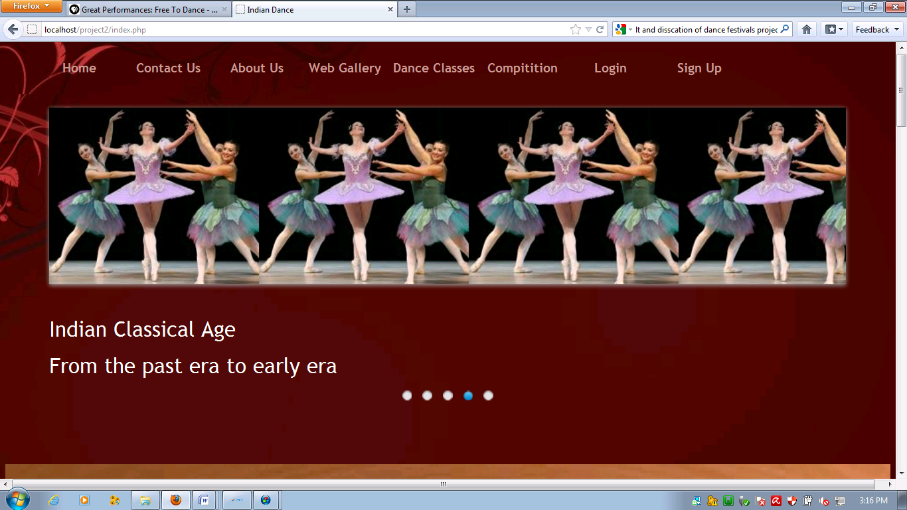

HOME

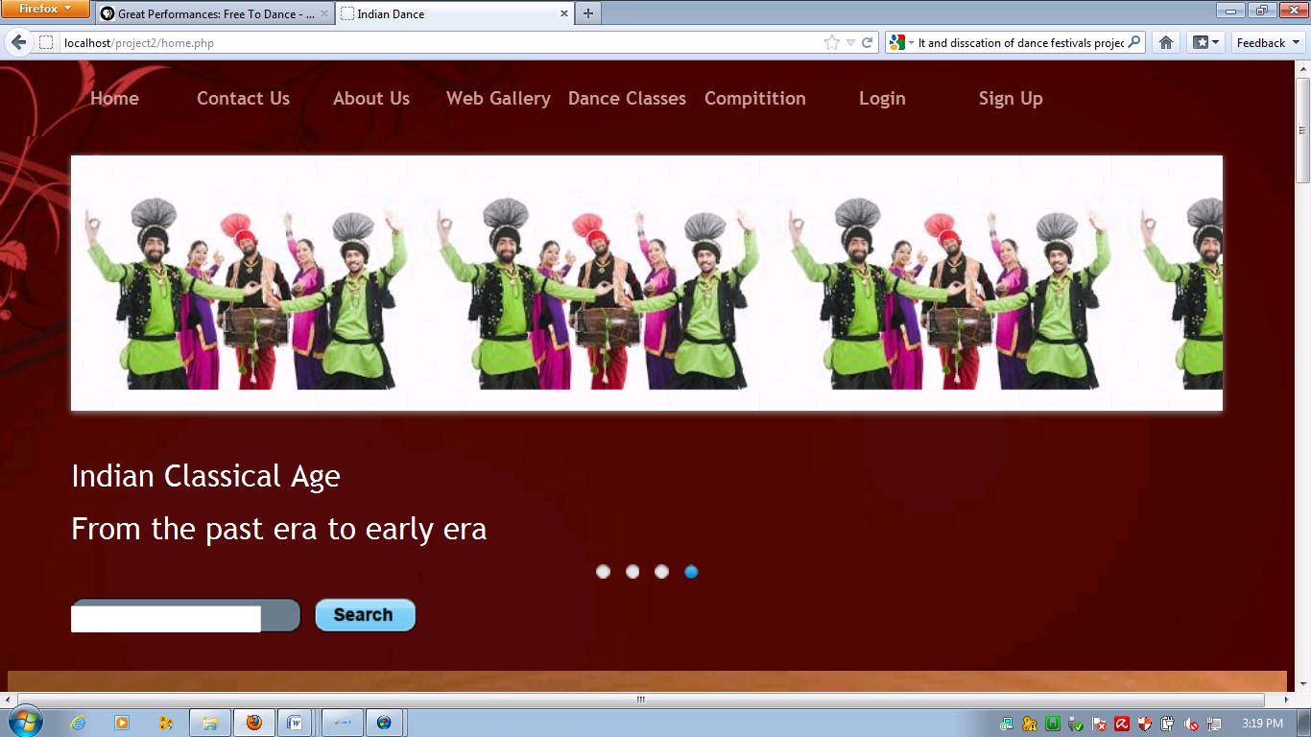

CONACT US

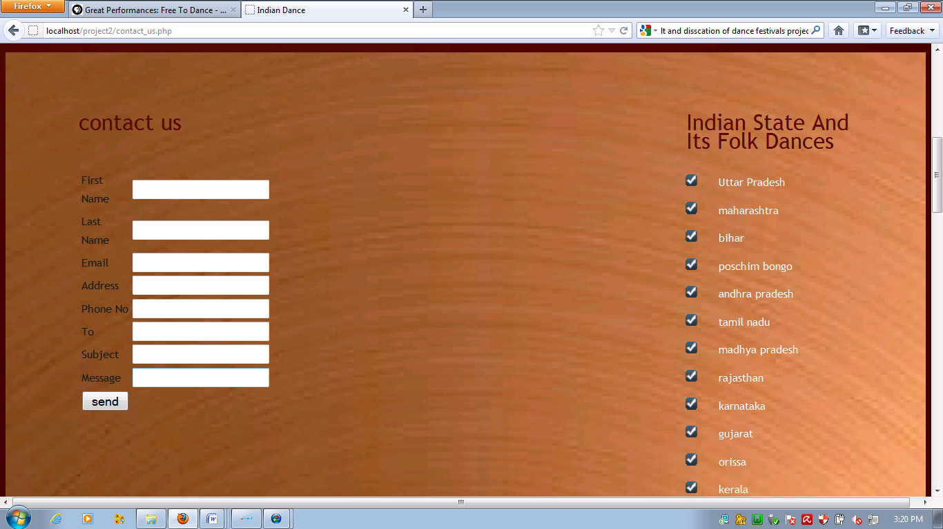

ABOUT US

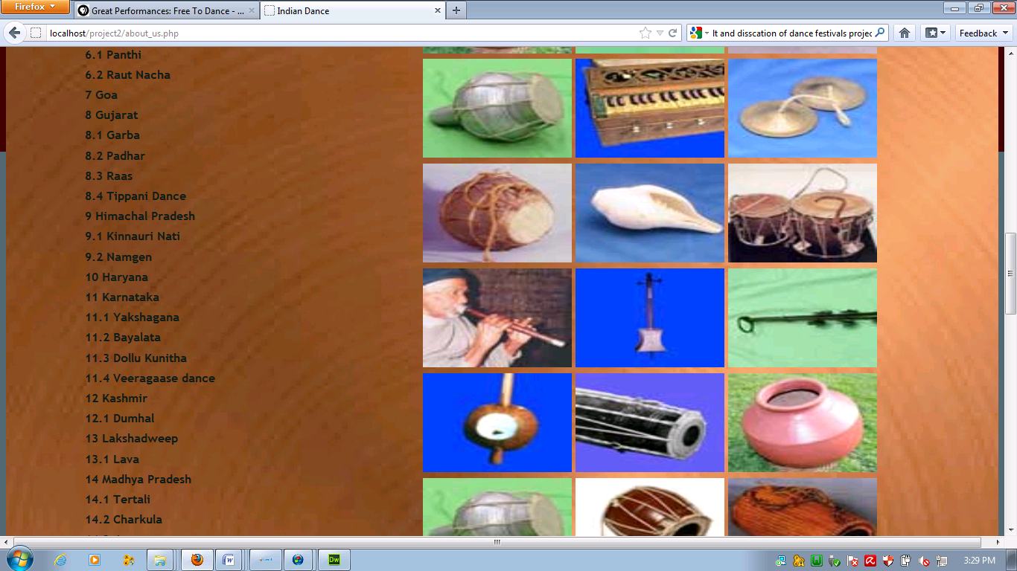

WEB GALLERY

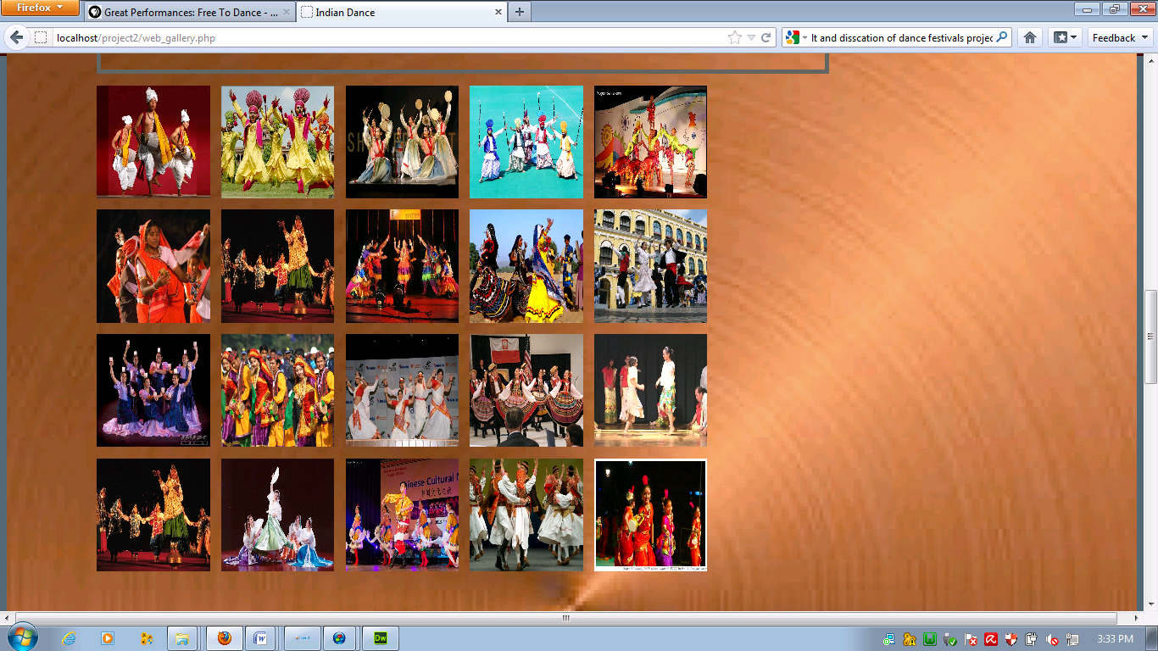

DANCE CLASSES

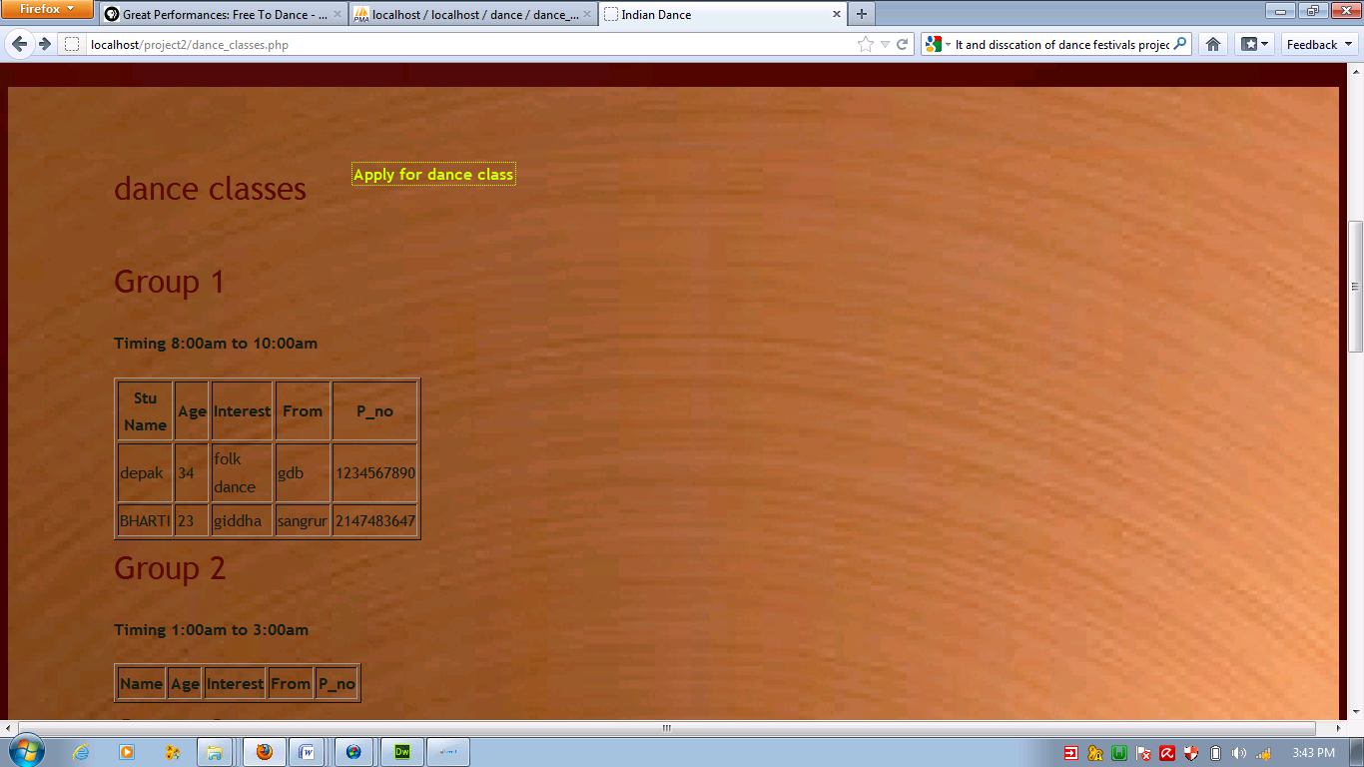

COMPITION

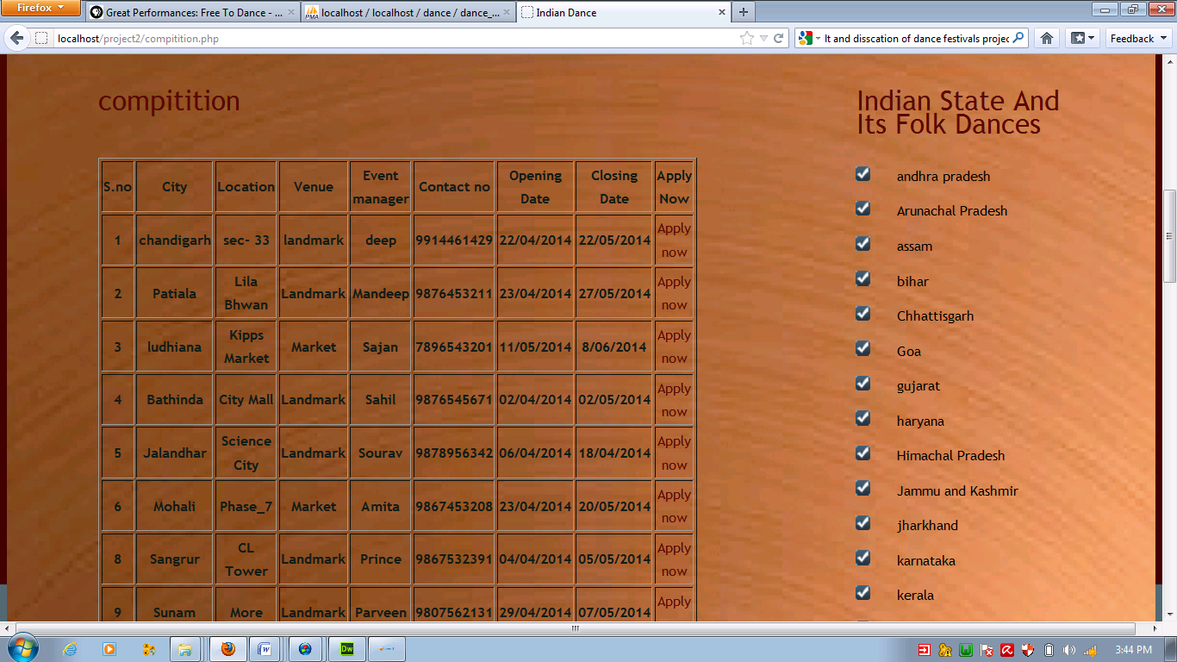

LOGIN

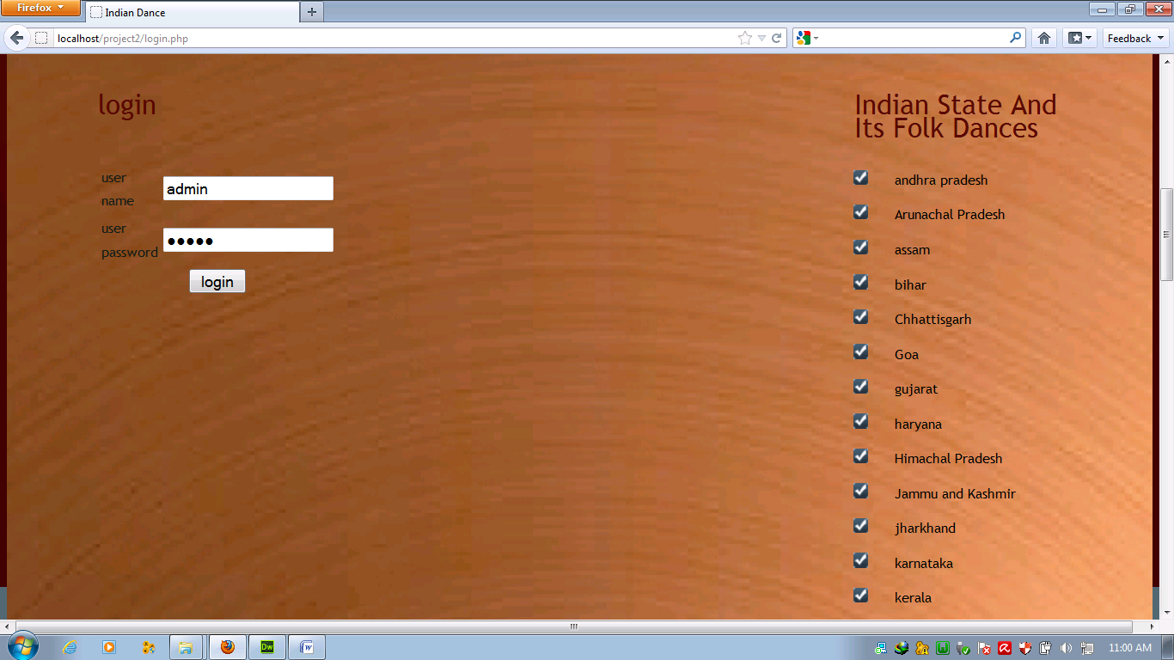

SEARCH

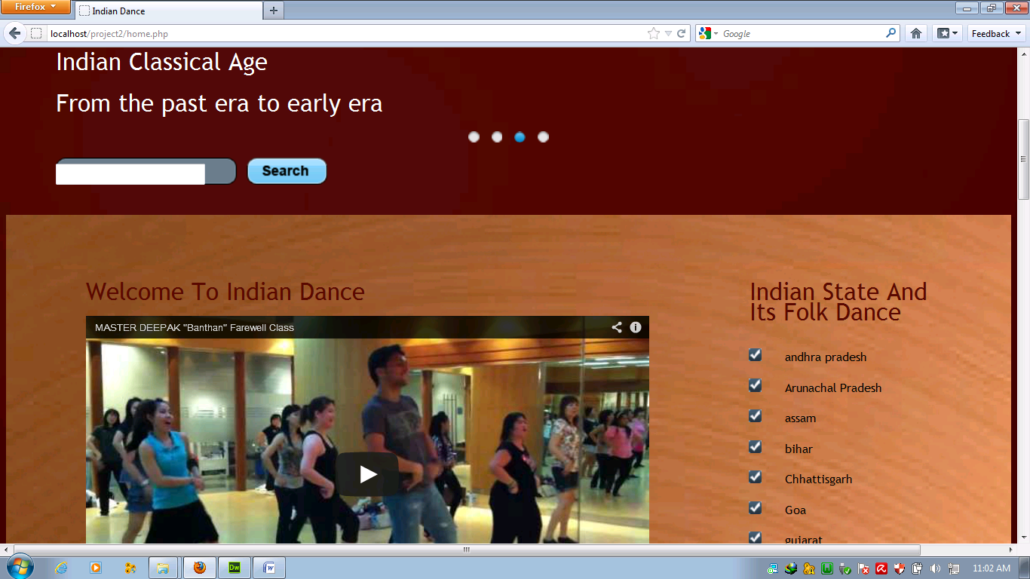

READ THE HOME PAGE

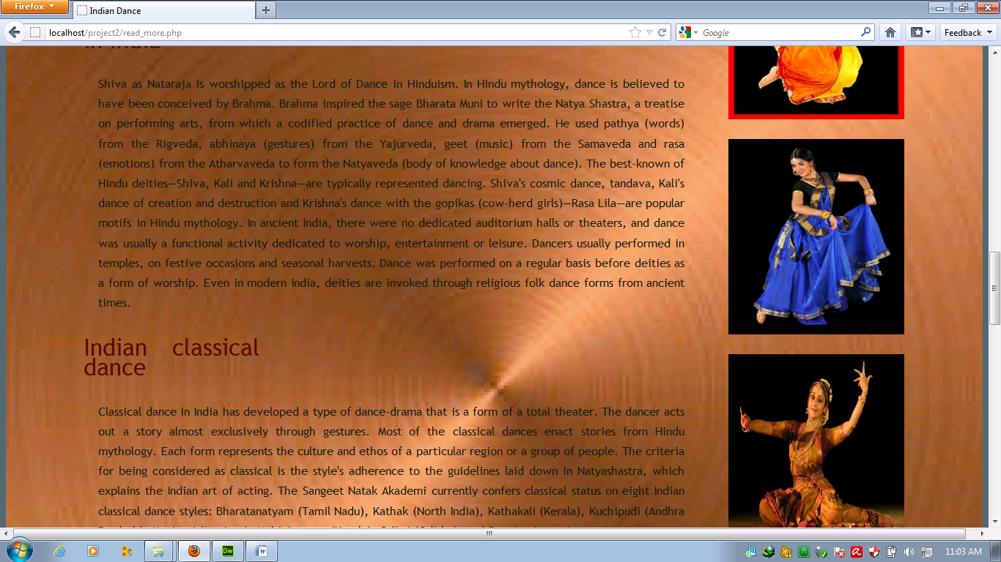

STATE

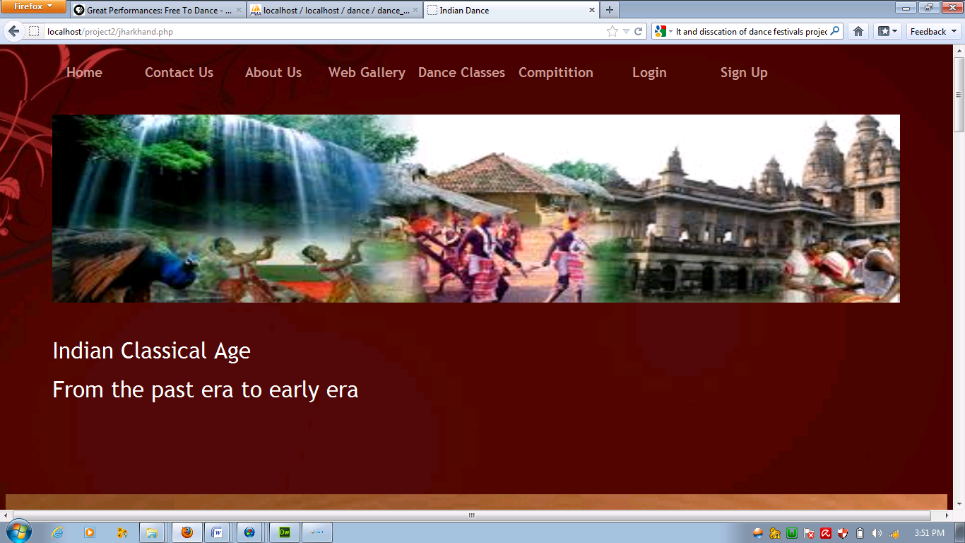

VIDEO

